Maintenance Reminder
Burke Porter Machinery

Overview:
The Maintenance Reminder application has been designed to track normal maintenance items and provide a warning message when each maintenance interval has expired. Maintenance Items can be added and removed as needs change. The application also has the capability of keeping notes for each maintenance items to use as a type of maintenance history.

Figure 1 shows the main display window.
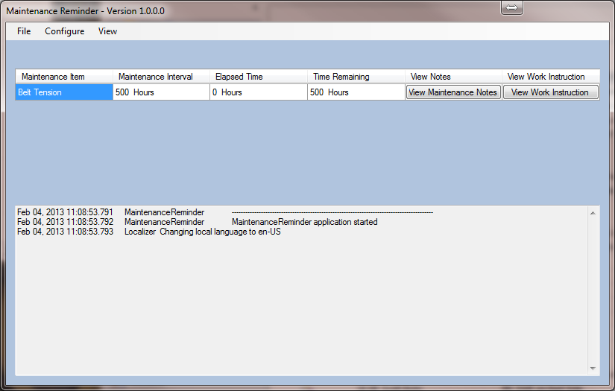
Figure 1

The top portion of the window displays a table showing each configured maintenance item. You will notice the configured maintenance interval is displayed as well as the amount of machine in use time elapsed since the last maintenance period. In-use time is measured as the time when the retaining rollers are in the raised position. The amount of time remaining until the next maintenance period is also displayed. Near the right side of the table is a button to enable maintenance personnel to view and enter maintenance notes for each maintenance item. This would mainly be used if a maintenance technician was at the machine and noticed something out of the ordinary and wanted to note it for reference later. At the far right of the table is a button to allow maintenance personnel to view the work instruction documentation.
The text window at the bottom of the window shows the software log and what actions have been taken.
Adding/Removing Maintenance Alerts:
Any number of maintenance alerts can be configured. Begin by selecting Maintenance Items from the Configure menu on the main window (Figure 1). The window in Figure 2 will be displayed.
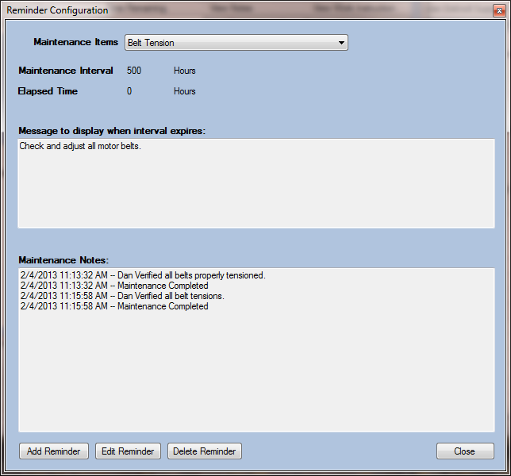
Figure 2

This window allows the user to view the specifics about any configured maintenance alert by selecting the name of the maintenance item from the drop down box at the top of the screen. To add a new maintenance item, click the Add Reminder button at the bottom left corner of the window. A new dialog box (Figure 3) will be displayed. Fill in the name of the maintenance item, the alert interval and a message to display when the interval expires. The Browse button allows you to link to a document containing a work instruction. Just click the Browse… button and navigate to and select the document containing the work instruction.
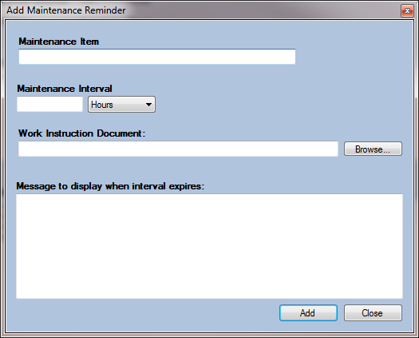
Figure 3

After all edits have been made, click the Add button. If any of the information in a maintenance alert is not correct, click the Edit Reminder button (Figure 2) to correct the information. If a maintenance item is no longer required, click the Delete Reminder button (Figure 2). The list of currently configured maintenance alerts will be displayed (Figure 4). Select the reminders to be removed and then click the Delete button.
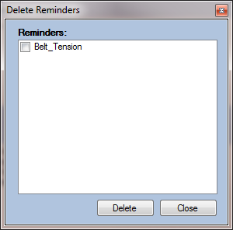
Figure 4
Closing Maintenance Alerts:
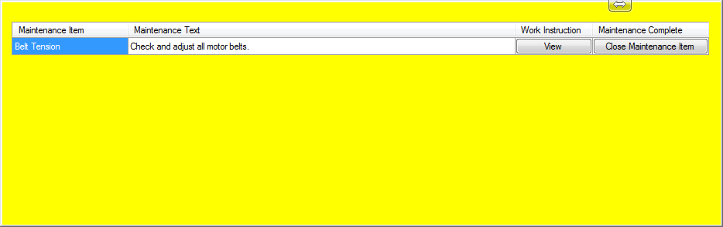
Figure 5

Figure 5 shows the expired maintenance item form. When a maintenance interval expires, the window in Figure 5 will be displayed. The window will always be the top-most window and cannot be closed or hidden until all expired maintenance items have been attended to. All expired maintenance items will be listed in the window. A button will be included under the Maintenance Complete column of the table. Clicking this button will bring up the window in Figure 6 that will allow the maintenance personnel to close the maintenance item and reset the maintenance timer. Prior to the window displaying, the maintenance engineer must enter the appropriate password. The password ensures that only specific individuals can close maintenance items.

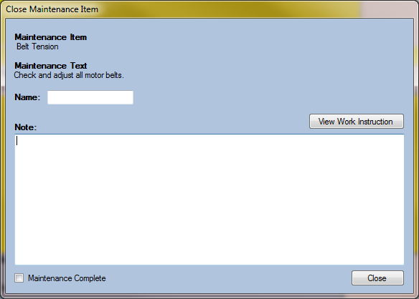
Figure 6
The maintenance item and the text for the maintenance item will be listed in the window. The maintenance engineer will be required to enter their name as well as notes regarding the maintenance that was performed. If the maintenance item is complete, be sure to select the Maintenance Item Complete box in the bottom left of the window. If more work needs to be completed (order new parts, etc), leaving the Maintenance Item Complete box un-checked will allow the maintenance item to remain open so it is not forgotten. The maintenance interval will not be reset unless the Maintenance Item Complete box is checked.

In addition to the expired maintenance item form (Figure 5) being displayed when a maintenance item has expired, a machine fault will be set and will be visible on the main CCRT display. The machine fault is mainly an information message and will not prevent the machine from operating. When the maintenance item is closed, the machine fault will also be cleared.

